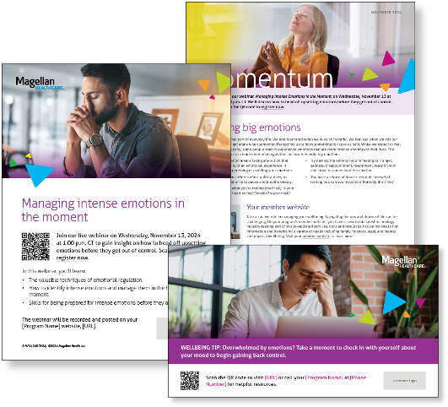
Monthly Campaign and Webinars
Monthly Campaign Theme
Handling big emotions
Emotions are a normal part of everyday life. While we expect to feel a range of emotions regularly, some people start to experience emotions that are more intense and impact their lives. The good news is that we can learn emotional regulation, or, how to handle big emotions. Learn more in this month’s newsletter.

Monthly Live Webinar
Managing intense emotions in the moment
November 13. Register here: 1 p.m. CT
Join this webinar to:
- Define emotional regulation.
- Identify intense emotions and how to manage them in the moment.
- Discover skills to prepare for intense emotions before they arise.

Most-Recent Webinar Recording
Did you miss the live webinar on September 11: Social Drinking versus Problem Drinking: What's the Difference? View the recording here.

Financial Wellbeing Monthly Webinar
Retirement: Understanding Medicare
November 12th. Register here: 11 a.m. CT | 2 p.m. CT
Medicare is a complex system, but understanding your coverage options can be essential to getting the healthcare you need. This event covers some of the basics of Medicare, including the different parts and what they cover, eligibility requirements, and enrollment periods. We’ll also discuss considerations for choosing a plan, maximizing your benefits, and navigating the Medicare system.

