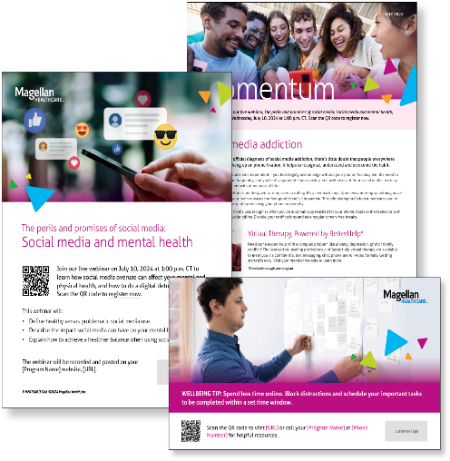
Monthly Theme – Employees
Social Media Addiction
While there is no official diagnosis of social media addiction, there’s little doubt that people everywhere experience it. To hang up on phone fixation, it helps to recognize, understand and overcome the habit. Learn more in this month’s newsletter.

Monthly Webinar
The perils and promises of social media: social media and mental health
July 10th. Register here: 1:00 pm CT
Join this webinar to:
- Define healthy versus problematic social media use.
- Describe the impact of social media on our mental health.
- Explain how to achieve a healthier balance when using social media.

Financial Wellbeing Monthly Webinars
Managing Financial Needs of Children & Aging Parents
July 9th. Register here: 11 am CT | 2 pm CT
Navigating personal finances can be daunting for anyone, but if you support your children and aging parents or grandparents, you are likely facing much greater challenges than most. Help has arrived! We’ll show you how to assess your financial and personal capacity and set realistic boundaries to help you through this stage of life. We’ll talk about how to handle setbacks and remain resilient, and we’ll provide resources and tools to help you manage your financial goals.

Investing Spotlight: Your Long-Term Strategy
July 25th. Register here: 11 am CT | 2 pm CT
Markets can be unpredictable. When times get difficult and investment values change, keeping your original investment strategy in mind can be challenging. This event will address the emotions that might interfere with your long-term plan and explain the difference between business and market cycles. Together, we will explore how you might conquer fears, emotions, and risk tolerance when investing and how to stay focused on your overall investment goals.

Special Campaign
July is Black, Indigenous and People of Color (BIPOC) Mental Health Awareness Month
This year’s theme is Recognizing BIPOC mental health: Cultivating culture, community and connection. Read the attached materials to learn more.
- Email it to your workforce
- Post it on your Organization’s Benefits Intranet
- Print and post in lunch or break rooms

