Monthly Theme – Employees
Changing perceptions
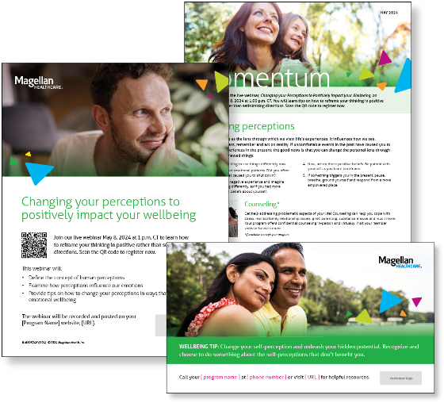
Perception serves as the lens through which we view life’s experiences. It influences how we see, understand, process, remember and act on reality. If uncomfortable events in the past have caused you to avoid certain experiences in the present, the good news is that you can change the personal lens through which you once viewed things. Learn more in this month’s newsletter.

Monthly Webinar
Changing your perceptions to positively impact your wellbeing | May 8
Join this webinar to:
- Define perceptions.
- Describe how perceptions influence our emotions.
- Identify tips to change your perception to improve emotional wellbeing.
Register here

Financial Wellbeing Monthly Webinars
Balancing Your Financial & Emotional Well-being | May 14
Register here: 11 am CT | 2 pm CT
Stress is something we all experience. Financial AND emotional strains are both common, routinely appear together, and can significantly influence our lives. Successfully reducing these stressors is key to overall wellness. We’ll walk through several financial and emotional challenges and offer tips on how to manage them. We’ll also talk about how to work with resources and how professionals can help.

Smart Money Moves: Tips for Major Purchases | May 30
Register here: 11 am CT | 2 pm CT
Whether it’s a car, living room furniture, or a washer and dryer, big purchases take some special planning. We will discuss factors such as buying now versus later, saving versus financing, and buying versus leasing. We’ll also explore credit and budget implications, as well as strategies for planning ahead and saving money in the long term.

Special Campaign
May is Mental Health Month
This year’s theme is Moving for mental health: Exploring activities to improve your overall wellbeing. Review the awareness campaign materials to learn how exercise influences your mental wellbeing and tips to get started with exercise.

