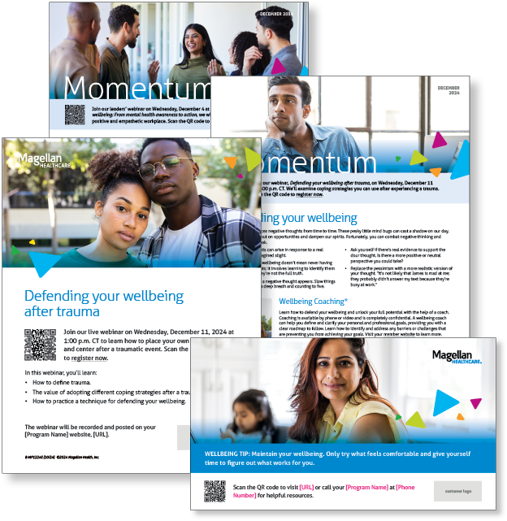
Monthly Campaign and Webinars
Monthly Campaign Theme – Defending Your Wellbeing
Defending your wellbeing
Everyone experiences negative thoughts from time to time. These pesky little mind bugs can cast a shadow on our day, leading us to miss out on opportunities and dampen our spirits. Fortunately, you can combat negative thinking and improve your outlook. Learn more in this month’s newsletter.

Monthly Live Webinar
Defending your wellbeing after trauma
December 11 | Register here: 1:00 p.m. CT
Join this webinar to:
- Define trauma.
- Explain different coping strategies to use after trauma.
- Practice a technique to defend your wellbeing.
Monthly Theme – Managers
Mental health awareness
More than ever, leaders play a crucial role in promoting mental health and wellbeing among their teams. By fostering a caring and supportive environment, managers can significantly impact morale, productivity and overall job satisfaction. Learn more in this month’s newsletter.

Monthly Webinar – Managers
Supporting employee wellbeing: From mental health awareness to action
December 4 | Register here: 1:00 p.m. CT
Join this webinar to:
- Define mental health awareness in the workplace.
- Describe characteristics of a wellbeing-focused workplace.
- Identify how to integrate wellbeing-focused strategies into your leadership.

Most-Recent Webinar Recording
Did you miss the live webinar on October 9: Feeling Stuck? Get Unstuck? View the recording here.

Financial Wellbeing Monthly Webinar
Smart Tax Moves: Opportunities to Save
December 10 | Register here: 11:00 a.m. CT and 2:00 p.m. CT
This event looks at several tax planning strategies that many people don’t take full advantage of even though they qualify. These include making sure you have the appropriate tax withheld, maximizing your retirement plan contributions, and investing with taxes in mind. We recommend that before you take any tax action, consult with a tax expert to see how these tax planning tips would apply to your specific situation.

