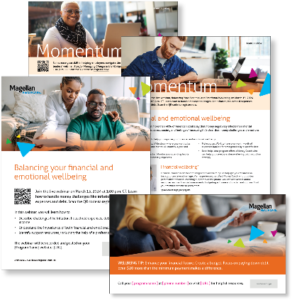
Monthly Theme – Employees
Financial and emotional wellbeing
Did you know that more than 40% of American adults say that money negatively affects their mental health—leading to stress, anxiety and feelings of insecurity? It’s clear that money challenges and emotions are closely linked. In this month’s newsletter, learn helpful tips to improve your financial and emotional wellbeing.

Monthly Webinar – Employees
Balancing your financial and emotional wellbeing | March 13
Join this webinar to:
- Describe challenges like inflation, household expenses, debt and fluctuating income.
- Understand the importance of both financial and emotional wellbeing.
- Identify support resources, including the help of a professional.
Register here

Monthly Theme – Managers
Managing change
Everyone processes change in different ways and at different rates. However, as a leader, you play a critical role in effectively guiding staff through changes in the workplace. In this month’s newsletter, learn helpful these tips to help you motivate and encourage your team.

Monthly Webinar – Managers
Tips for managing change in the workplace | March 27
Join this webinar to:
- Describe types of change and how these affect employees.
- Identify tips to help leaders cope with change.
- Explain coping skills anyone can use when facing change.
Register here

Financial Wellbeing Monthly Webinars
Women & Money | March 12
Register here: 11 am CT | 2 pm CT
Women often face unique financial challenges. This event covers some of the basics of personal finance, focusing on strategies that are relevant for women. It also looks at planning for life events like starting a family and juggling multiple financial goals. Whether you’re just starting your financial journey or looking to take your financial skills to the next level, join this event for the tools and confidence to move forward.

Unlocking the Power of Your Credit | March 28
Register here: 11 am CT | 2 pm CT
Credit plays a vital role in achieving financial health, yet many people struggle to understand and effectively manage their credit. In this informative and engaging session, we’ll dive into the fundamentals of credit, including how it works, how to establish and maintain good credit, and common
mistakes to avoid.

Special Campaign
March 18-24 is National Drug and Alcohol Facts Week
Learn more about substance use disorder and treatment options in this helpful flyer.

