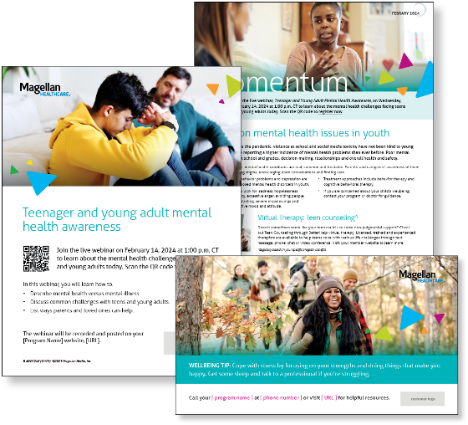
Monthly Theme
Protecting youth mental health
Recent events like the pandemic, violence at school and social media toxicity have not been kind to young people. Youth are reporting a higher incidence of mental health problems than ever before. Poor mental health can impact school and grades, decision-making, relationships and overall health and safety. Learn more in this month’s newsletter.

Monthly Webinar
Teenager and young adult mental health awareness | February 14
Join this webinar to:
- Describe mental health versus mental illness.
- Discuss common challenges with teens and young adults.
- List ways parents and loved ones can help.
Register here

Financial Wellbeing Monthly Webinars
Retirement: Getting Started | February 13
Register here: 11 a.m. CT | 2 p.m. CT
When mid-to-late career, a critical step towards a solid retirement plan is creating and establishing savings goals. Knowing there are many competing needs for the dollars you save, we’ll review goal-setting strategies that can help you stay on track. Learn about estimating how much you may need to save by the time you retire, calculating the amount to invest each month and retirement options.

Smart Tax Moves: Understanding Tax Returns | February 29
Register here: 11 a.m. CT | 2 p.m. CT
This event is designed to help you better understand and feel more confident about the tax filing process. Learn about the basics of tax returns, such as determining your filing status and calculating your taxable income, and more advanced topics like tax deductions and credits. We’ll also explore the different types of tax returns, including federal and state returns, and how to file each one.

Special Campaign
February is National Cancer Prevention Month
The time after a cancer diagnosis can be difficult. Everyone deals with cancer in their own way. Learn more about coping with stress and building resilience.

