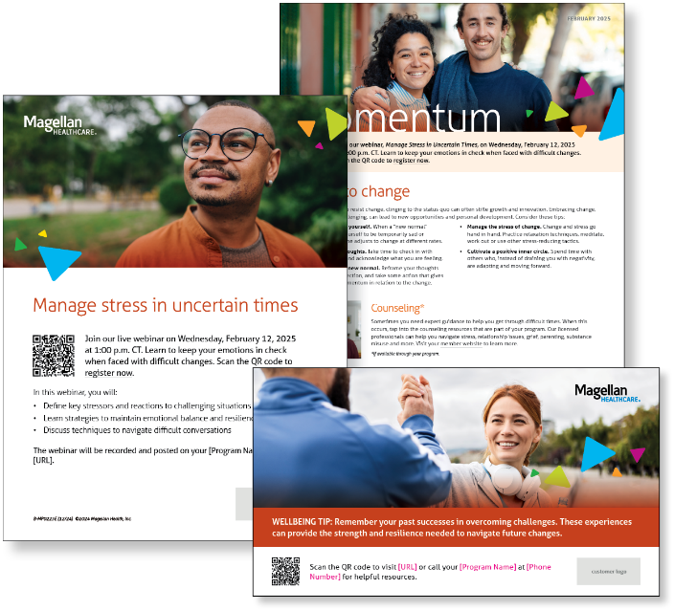
Monthly Campaign and Webinars
Monthly Campaign
Adapt to change
While it’s natural to resist change, clinging to the status quo can often stifle growth and innovation. Embracing change, even when it’s challenging, can lead to new opportunities and personal development. Find helpful tips in this month’s newsletter.

Monthly Live Webinar
Manage Stress in Uncertain Times
February 12th | Register here: 1:00 p.m. CT
Join this webinar to:
- Define key stressors and reactions to challenging situations
- Learn strategies to maintain emotional balance and resilience
- Discuss techniques to navigate difficult conversations

Most-Recent Webinar Recording
Did you miss the latest live webinar: Defending Your Wellbeing After Trauma? View the recording here.

Financial Wellbeing Monthly Webinars
Smart Tax Moves: Understanding Tax Returns
February 11th. Register here: 11:00 a.m. CT | 2:00 p.m. CT
This event is an overview designed to help you better understand and feel more confident about the tax filing process. Learn about the basics of tax returns, such as determining your filing status and calculating your taxable income, and more advanced topics like tax deductions and credits. We’ll also explore the different types of tax returns, including federal and state returns, and how to file each one.

Tips for Tough Conversations
February 27th. Register here: 11:00 a.m. CT | 2:00 p.m. CT
Does the thought of necessary money conversations make you want to run for the hills? Our Money Coaches are here to turn that financial frown upside down! They’re armed with examples of conversation starters and tactics that have led to open and effective financial discussions. Whether you’re negotiating an allowance with your child, trying to create a budget with your partner, or talking about estate planning with a parent, don’t miss these insights!

