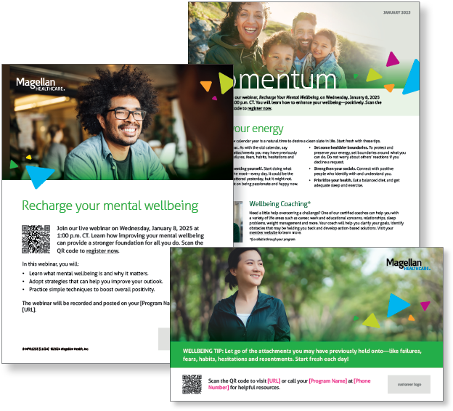
Monthly Campaign and Webinars
Monthly Campaign
Reset your energy
The kickoff of a new calendar year is a natural time to desire a clean slate in life. Find helpful tips in this month’s newsletter.

Monthly Live Webinar
Recharge your mental wellbeing
January 8 | Register here: 1:00 pm CT
Join this webinar to:
- Describe mental wellbeing and why it matters
- Learn strategies to improve your outlook
- Practice simple techniques to boost overall positivity

Most-Recent Webinar Recording
Did you miss the latest live webinar: Managing intense emotions in the moment? View the recording here.

Financial Wellbeing Monthly Webinars
Mastering Money Basics
January 14 | Register here: 11:00 am CT | 2:00 pm CT
If you want to feel confident about your finances, consider using a plan with the following components: controlling spending, managing debt, prioritizing savings, and maintaining excellent credit. Avoiding or losing focus on any of these elements can add stress to your life. This event explains the importance of each one and helps you get started.

Achieving Goals – Success Stories
January 23 | Register here: 11:00 am CT | 2:00 pm CT
New Year’s resolutions falling flat? Goals feeling more like wishful thinking? Don’t fret! MSA Money Coaches are here to save the day! This isn’t your run-of-the-mill broadcast. We’re giving you a backstage pass to meet our coaches as they provide examples of how people overcome setbacks and those inevitable temptations to change priorities.

