MAGELLAN BULLETIN - JUNE 2024 MOMENTUM ENGAGEMENT CAMPAIGN AND WEBINARS

Monthly Theme – Employees
Multigenerational workplace
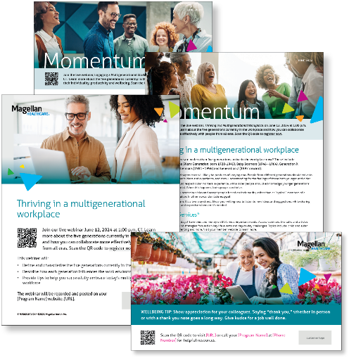
Did you know there are no less than five generations active in the workplace now? These include Traditionalists (the Silent Generation, born 1928-1945), Baby Boomers (1946 – 1964), Generation X (1965 – 1980), Millennials (1981 – 1996) and Generation Z (1997 onward). Your colleagues and supervisors will likely be products of varying eras. People from different generations should strive to learn from each other’s ideas and experience, and show understanding for the feelings of those both younger and older Learn more in this month’s newsletter.

Monthly Webinar
Thriving in a multigenerational workforce | June 12
Join this webinar to:
- Describe the five generations currently in the workplace.
- Learn how each generation influences the workplace.
- List tips to help you successfully embrace the multigenerational workforce.
Register here

Monthly Theme – Managers
Multigenerational workforce
Knowing your colleagues and staff are likely from different eras, they have differing motivations, expectations and work styles will help you find value in everyone’s perspectives, promoting stronger teamwork and creativity. Learn more in this month’s newsletter.

Monthly Webinar – Managers
Engaging a multigenerational workforce | June 26
Join this webinar to:
- Describe the five generations currently in the workplace.
- Learn how each generation influences the workplace.
- List tips to help you and your staff embrace the multigenerational workforce.
Register here

Financial Wellbeing Monthly Webinars
Relationships & Money
June 11th. Register here: 11 am CT | 2 pm CT
Money can be a tricky subject, especially when it comes to relationships. This event explores the various ways that finances can impact relationships and how you might approach money in a healthy and sustainable way. Learn best practices to improve communication skills with friends and family.

Investing Resources: Professionals vs. DIY
June 27th. Register here: 11 am CT | 2 pm CT
This event looks at the differences between online investing platforms versus the more traditional practice of meeting face-to-face with an investment advisor. We’ll discuss how to find an investment professional, the importance of monitoring your investments, and adjusting your portfolios over time. Lastly, we will talk about how you might create an action plan to help with your next steps.

Special Campaign
June is LGBTQIA+ Pride Month
While progress continues in support of LGBTQIA+ communities, many challenges persist. Read the attached flyer to learn more about how you can support LGBTQIA+ individuals.

