Subject line: Magellan Bulletin - April 2024 Momentum Engagement Campaign and Webinars

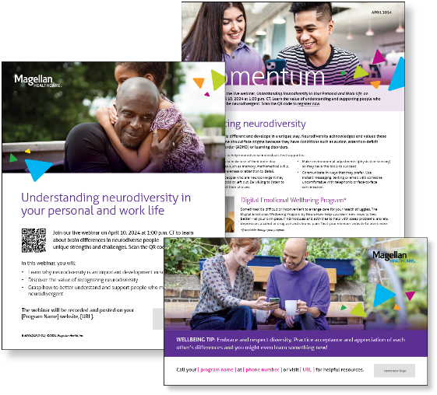
Monthly Theme – Employees
Embracing neurodiversity
Everyone’s brain is different and develops in a unique way. Neurodiversity acknowledges and values these differences. No one should face stigma because they have conditions such as autism, attention-deficit hyperactivity disorder (ADHD) or learning disorders. In this month’s newsletter, learn tips to help neurodiverse individuals feel supported.

Monthly Webinar
Understanding neurodiversity in your personal and work life | April 10
Join this webinar to:
- Describe neurodiversity.
- Discover the value of neurodiversity at work and home.
- Name strategies to support neurodivergent people.
Register here

Financial Wellbeing Monthly Webinars
MSA’s Keys to Financial HealthSM: Unlock Your Potential | April 9
Register here: 11 am CT | 2 pm CT
Achieving financial wellbeing is essential for a happy and secure life. MSA has identified five keys that can help you unlock your financial potential. Let’s walk through each key and discuss what success looks like. Explore how to take control of spending, leverage credit and debt, prepare for the unexpected, build your future, and achieve your goals. Master each of these keys to improve your finances, feel better, and enjoy less stress.

Investing Basics: Growing Your Wealth | April 25
Register here: 11 am CT | 2 pm CT
Investing can be intimidating, especially if you’re new to the game. We’ll talk about the basics of investing, including different types of investments and evaluating risk and return. Whether you’re saving for retirement or just want to grow your wealth, this event can provide education, tools, and confidence to help you get started.

Special Campaign
April is Autism Acceptance Month
This year’s theme is Embracing neurodiversity: Fostering inclusive and thriving environments. Review the awareness campaign materials to learn myths vs. facts about neurodiversity and tips to support neurodiverse colleagues.

