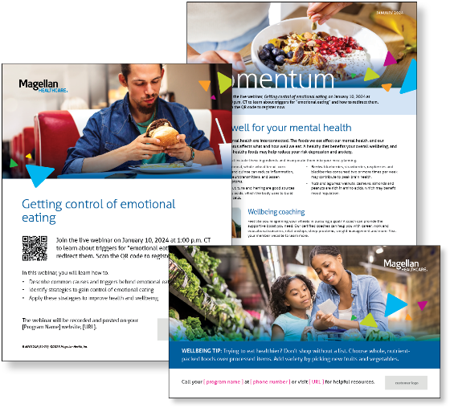
Subject line: Magellan Bulletin – January 2024 Momentum Engagement Campaign and Webinars

Monthly Theme
Eating well for your mental health
Nutrition and mental health are interconnected. The foods we eat affect our mental health, and our mental health status affects what and how well we eat. A healthy diet benefits your overall wellbeing, and consuming brain-healthy foods may help reduce your risk depression and anxiety. Learn more in this month’s newsletter.

Monthly Webinar
Getting control of emotional eating | January 10
Join this webinar to:
- Describe common causes and triggers behind emotional eating
- Identify strategies to gain control of emotional eating
- Discover how to apply these strategies to improve health and wellbeing
Register here

Financial Wellbeing Monthly Webinars
Juggling Financial Priorities | January 9, 2024
Register here: 11 a.m. CT | 2 p.m. CT
This or that? Should I save for retirement or invest for my child’s college education? Should I save or pay off debt? When life happens, which goals should I focus on? This event will explore working on multiple financial goals at the same time. We’ll discuss the primary objectives to keep in mind and helpful tips as you navigate your personal financial journey.

Money and Mentoring: Tips for Parents | January 25, 2024
Register here: 11 a.m. CT | 2 p.m. CT
Managing the cost of parenthood while trying to raise financially responsible kids can be challenging. Join this event to learn about budgeting for parenthood, like childcare expenses, education, and unexpected costs. You can also learn about ways to teach your kids the value of money and introduce them to budgeting, saving, and investing. Help your family build a strong financial foundation by nurturing your financial skills and your children’s.

